AGI-4-Knowledge Graph RAG Engine
SOFTWARE DESIGN DOCUMENT (SDD)

Course: CS 4850 – Section 02 – Senior Project
Semester: Fall 2026
Advisor: Professor Perry
Date: 9-20-26
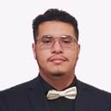 |  |  |  | 
Team Leader  Developer | Developer | Developer | Documentation  Tester | Developer  Tester
Jose Portillo | Ian Blanchard | Phat Pham | Kris Prasad | Gabriel Oyarekhua

Table of Contents
1. Introduction and Overview 3
2. Design Consideration 3
2.1 Assumptions and Dependencies 3
2.2 General Constraints 4
2.3 Development Methods 4
3. Architectural Strategies 5
4. System Architecture 6
4.1. Document Ingestion and Query Workflow 7
4.2. Data Flow Diagrams (DFD) 8
4.2.1. Context DFD (Level 0 DFD) 8
4.2.2. Level 1 DFDs 8
4.3. Partial Entity Relationship Diagram 9
4.4. Proposed Graph Schema 11
5. Detailed System Design 11
5.1. Classification 11
5.2. Definition 12
5.3. Constraints 12
5.4. Resources 12
5.5. Interface/Exports 13
6. Glossary 13
7. Bibliography 14

1. Introduction and Overview
This project will develop a GraphRAG pipeline that moves beyond basic vector-similarity search. The system will ingest unstructured domain documents, automatically extract entities and relationships using an LLM, construct a persistent Knowledge Graph, and connect it to a vector database. By enabling multi-hop graph traversal and hybrid search, the system will provide grounded context for complex reasoning queries and allow users to trace relationships and sources used to generate responses.
The frontend will display generated answers from Qwen 3.5:0.8b alongside source nodes and the graph path used to develop the answer. A basic authentication system using Supabase Auth with Google sign-in will be used. Users will be able to upload PDFs and keep their documents and indexed data in their accounts between sessions.
Some specifics of the system will include incremental re-indexing after document adjustment or removal and a side-by-side comparison of standard RAG to Knowledge Graph RAG. The benchmarks will be a complete tab in the frontend UI, separate from the home tab and graph visualizer.
Further expanding the project's scope, the web UI will have an expanded graph explorer with interactive visualization and deeper analysis. Beyond the graph path tracing, users will be able to search and filter graph nodes, expand connected nodes, and inspect source information at varying levels of detail.
This document describes the technology stack, data stores, main system components, and process flows used to meet the requirements established in the Software Requirements Specification.

2. Design Consideration

2.1 Assumptions and Dependencies
The Knowledge-Graph RAG system is based on several assumptions and dependencies related to the software environment, data sources, external services, and user interactions. These are described below.
Assumptions:
- Users have access to a modern desktop web browser, a Google account, and a stable internet connection.
- The documents provided to the system are PDFs with usable text and contain information relevant to the selected medical-domain corpus. Empty, unreadable, and image-only documents will be reported as failed.
- Users ask questions that relate to the information contained in the indexed documents of the corpus.
- Qwen 3.5:0.8b is available through Ollama for entity-relation extraction and context-based response generation.
- The knowledge graph will use predefined node and relationship types together with identifier and entity-normalization rules, to reduce inconsistent and duplicate records.
- The system has sufficient computational power to process documents, generate embeddings, execute graph queries, and respond to user queries. These capacity assumptions will be checked during prototype testing.
- Neo4j and Qdrant are available for the system’s operation.
Dependencies:
- The system utilizes Python as a programming language for backend and processing tasks.
- The system depends on Neo4j for the Knowledge Graph storage and query processing.
- The system depends on Qdrant for document chunk embedding storage and semantic similarity search.
- The system depends on Qwen 3.5:0.8b through Ollama for entity-relation extraction and response generation.
- The system uses LangChain to implement the ingestion, retrieval, and response generation pipelines.
- The web application depends on React for the frontend and FastAPI for communication between the frontend and backend.
- The system depends on Docker and Docker Compose to deploy the application and required services consistently.
- The system requires access to the relevant source documents and metadata for ingestion and retrieval tasks.
The system also depends on Supabase Auth and Google for sign-in, Supabase Storage for PDF files, and Supabase Postgres for document metadata and processing states. An embedding model will be selected for Qdrant indexing; the same model and settings will be used to embed document chunks and user queries.

2.2 General Constraints
The input format will be text-based PDF. Each document, chunk, graph record, and vector record will retain identifiers that link the data to its source and account. Source locations will be retained for citations and document inspection.
The initial corpus will be available in each account's workspace. Adding, replacing, or removing documents will affect only the requesting account's workspace.
The graph will use a predefined set of node and relationship types.

2.3 Development Methods
The system will be developed in stages, beginning with document ingestion and indexing, followed by retrieval, response generation, graph exploration, and the comparison tab. Team members will work in GitHub branches and merge changes through pull requests.
Testing will cover valid and invalid PDFs, duplicate uploads, schema validation, source references, account isolation, retries, document modifications, and retrieval without usable evidence. Once the prototype is developed, it will be tested with concurrent users to check system capacity.
Benchmark testing will compare Standard RAG and GraphRAG using fixed queries and the same permitted documents, generation settings, and model. The team will assess response correctness and reference accuracy against the sources.

3. Architectural Strategies
The system separates the React interface, FastAPI backend, ingestion pipeline, query handling, and data stores. React handles user interactions while FastAPI checks requests and handles the backend components [1], [2]. Python and LangChain will be used for the GraphRAG pipeline [3].
Neo4j stores entities and relationships for graph traversal [4]. Qdrant stores chunk vectors and source information for semantic search [5]. Supabase retains original PDFs in a private bucket [6]. Supabase Postgres stores document metadata and processing states [7]. These data stores share identifiers so the system can combine related results and show their sources.
Qwen 3.5:0.8b will run through Ollama for extraction and response generation [8], [9], [10]. An embedding model will generate numerical vectors for Qdrant. Extracted entities and relationships will be checked against the graph schema before storage in Neo4j. This Qwen model will be used for the prototype and evaluated based on extraction quality and response quality. If these results are poor, then the model will be changed for the final deliverables.
Supabase Auth handles Google sign-in and sessions. FastAPI verifies the resulting access token and derives the account identifier from this [11], [12]. The application will not collect or store Google passwords. Secret API keys and service credentials will remain in backend environment variables and will not be included in frontend code or version control.
Progress and failures during document processing and query generation will be exposed to the user through concise text prompts on the UI. In the backend, there will be detailed logs for more targeted fixes. Docker will provide a consistent environment for the application services [13].
Partitioning the application into modules makes individual components easier to test and modify while limiting the impact of changes on the rest of the system. We are utilizing Supabase for this project because it brings authentication, database, and other features into one platform to reduce the amount of supporting infrastructure we need to build and maintain.

4. System Architecture
This diagram shows the main components and the direction of requests and returned results. Ingestion writes to the data stores, while query handling reads context and supports both generated answers and graph exploration. The authentication component uses Supabase Auth with Google sign-in, as described above. The "Document Store" in the diagrams consists of Supabase Storage for PDFs and Supabase Postgres for document metadata.
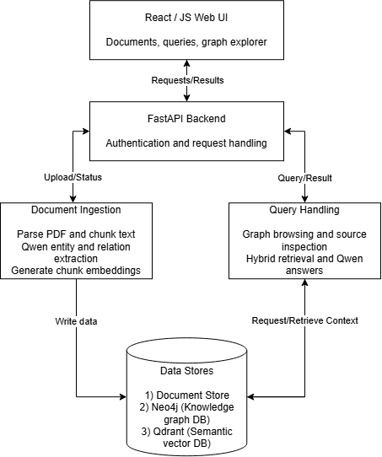
Figure 1. System architecture of the KG RAG Engine system.

4.1. Document Ingestion and Query Workflow

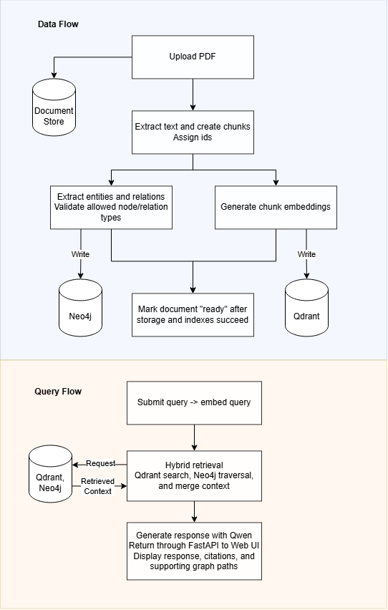
Figure 2. Document ingestion and query workflow.

4.2. Data Flow Diagrams (DFD)

4.2.1. Context DFD (Level 0 DFD)
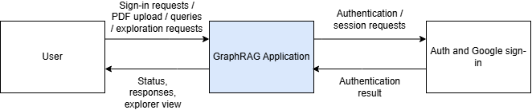
Figure 3. Context data flow diagram of the GraphRAG application.

4.2.2. Level 1 DFDs
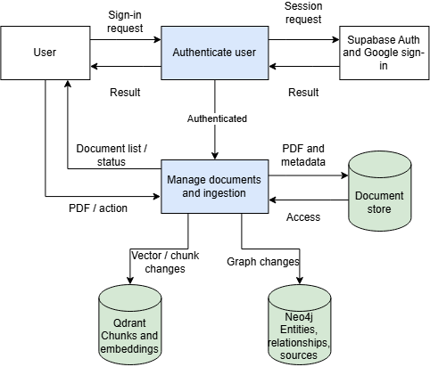
Figure 4. Level 1 data flow diagram for authentication and document ingestion.

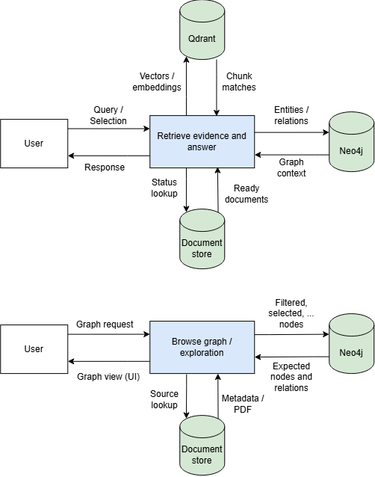
Figure 5. Level 1 data flow diagram for retrieval, response generation, and graph exploration.

4.3. Partial Entity Relationship Diagram

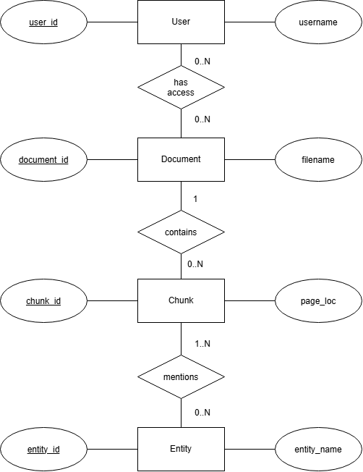
Figure 6. Partial entity relationship diagram for users, documents, chunks, and extracted entities.

As established in the SRS and in this design document, Supabase Postgres will store document metadata and account-to-document access records. User uploads will be associated with their uploading account, while the initial corpus documents may be available to multiple accounts. Qdrant will store chunk text, embeddings, and source metadata. Neo4j will store extracted entities, relationships, and chunk references.

4.4. Proposed Graph Schema
The following schema defines an initial set of medical entity and relationship types for the prototype. Our team will refine these as the project progresses.
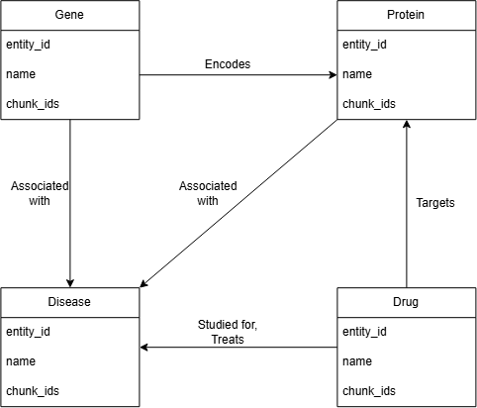
Figure 7. Proposed partial medical knowledge graph schema.
Repeated mentions identified as the same entity reuse the entity identifier within the account’s workspace. Each relationship has supporting chunk identifiers that correspond to document and page references.

5. Detailed System Design

5.1. Classification
React is the frontend subsystem, and FastAPI is the backend API. Document ingestion, retrieval and response generation, graph exploration, and RAG comparison are application modules. Data access and error handling are shared components on the backend.

5.2. Definition
The frontend provides account access and user interaction with FastAPI verifying requests and coordinating the modules in the application.
Document ingestion converts uploaded PDFs into source-linked chunks, graph records, and embeddings. Retrieval combines vector matches and graph context to generate responses. Graph exploration allows access to connected nodes and their source data. The comparison module includes Standard RAG and Knowledge Graph RAG results for the same query and document selection for the user to compare.
Data access maintains the current processing state of the documents, account isolation, and source references across the data stores. Error handling reports detailed logs to the backend for the team to test and concise prompts to the UI for the user to see.

5.3. Constraints
Interaction with the system requires a valid user account. In addition, account isolation must be enforced so altering a document from one account does not affect its usage from another account.
The input will be limited to PDFs with usable text and within the configured size limit. Chunks retain the document identifier and page number or range, and extracted entities and relationships need to fit the graph schema.
A document will only be considered 'ready' after file storage and indexes in Neo4j and Qdrant are successful. Failed or incomplete documents are excluded from retrieval. Retried jobs reuse the existing document identifier and replace incomplete index records to prevent duplicates. If a retrieval does not have usable evidence, then the system reports this with a text prompt to the user; they can then add supporting documents or try a new query.
Document chunks and queries will use the same embedding model. The two RAG pipelines in the comparison module will use the same document selection, generation settings, and model.

5.4. Resources
Supabase Auth provides Google sign-in support, Supabase Postgres holds metadata, and Supabase Storage holds PDFs. Qdrant stores chunk vectors, and Neo4j stores entities, relationships, and source references. Document processing uses the embedding model, LangChain, and Qwen through Ollama. Qwen 3.5:0.8b is the initial prototype model. Its extraction quality, response quality, and resource requirements will be evaluated during prototype testing. Renders in the UI, such as the graph explorer, use the browser resources.
To prevent conflicting actions on documents, updates will happen one at a time in order. This will help to prevent issues such as deadlocks and accessing non-existent information. For instance, if a user updates a PDF while a background job is creating its Neo4j and Qdrant data, then the system will finish the first indexing process completely before applying the document update. If a user deletes a document mid-process, any older tasks are blocked from writing to Neo4j or Qdrant.

5.5. Interface/Exports
Shared data types:
DocumentStatus: ‘processing’, ‘ready’, or ‘failed’.
DocumentRecord: Document identifier, filename, status, and optional processing/failure message.
SourceReference: Document identifier, chunk identifier, and page number or range.
Response: Answer text, source references, supporting graph paths, and completion, limited evidence, or failure information.
The following defines the main inputs and outputs for each of the core services in the application:
- Account Access
  - Inputs: Sign-in requests, sign-out requests, and optional display-name update.
  - Outputs: Session or authentication error, sign-out confirmation, and updated profile.
- Document Management
  - Inputs: PDF upload; replacement PDF; document identifier for status, retry, replacement, or removal.
  - Outputs: DocumentRecord, permitted document list, duplicate notice, or operation confirmation.
- Query
  - Inputs: Question and selected ‘ready’ document identifiers.
  - Outputs: Response, including a notice when no usable evidence is available.
- Comparison
  - Inputs: The same question and document selection for both retrieval methods.
  - Outputs: Separately labeled “Standard RAG” and “GraphRAG” Response, with independently reported failures.
- Graph Exploration
  - Inputs: Search text or node identifier, optional filters, and document selection.
  - Outputs: Matching or connected nodes and relationships, their identifiers, and source references.
- Source Access
  - Inputs: Document identifier and optional page location.
  - Outputs: PDF access and source location.
Failed service requests return an error and brief message. More detailed logs will be returned on the backend for the team to diagnose the issue, while more concise text prompts will appear on the frontend for the user to view.

6. Glossary
Chunks: Bounded passages of extracted document text stored with a source document identifier and page location.
Embedding: Numerical representation of text used for semantic similarity search.
Entities: Distinct items in source text which are represented as nodes in the Knowledge Graph.
GraphRAG: Retrieval Augmented Generation using a Knowledge Graph; response generation using vector search and graph relationships as context.
Hybrid retrieval: Retrieval combining semantic vectors with graph traversal.
Knowledge Graph (KG): A persistent collection of entities and relationships as nodes and edges, respectively.
User Interface (UI): Where the interactions between human users and the program occur.

7. Bibliography
[1] React, "React references." Available: https://react.dev/reference/react
[2] FastAPI, "FastAPI references." Available: https://fastapi.tiangolo.com/reference/
[3] LangChain, "LangChain documentation." Available: https://docs.langchain.com/
[4] Neo4j, "Neo4j documentation." Available: https://neo4j.com/docs/
[5] Qdrant, "Qdrant documentation." Available: https://qdrant.tech/documentation/
[6] Supabase, "Storage buckets." Available: https://supabase.com/docs/guides/storage/buckets/fundamentals
[7] Supabase, “Database.” Available: https://supabase.com/docs/guides/database/overview
[8] Ollama, "Ollama documentation." Available: https://docs.ollama.com/
[9] Ollama, "Qwen 3.5:0.8b model." Available: https://ollama.com/library/qwen3.5:0.8b
[10] Qwen, "Qwen documentation." Available: https://qwen.readthedocs.io/en/latest/
[11] Supabase, "Sign in with Google." Available: https://supabase.com/docs/guides/auth/social-login/auth-google
[12] Supabase, "JSON Web Token." Available: https://supabase.com/docs/guides/auth/jwts
[13] Docker, "Docker documentation." Available: https://docs.docker.com/

